A Project report on

***“*BLOOD BANK MANNAGEMNT SYSTEM*”***

**MASTER IN COMPUTER APPLICATIONS**

SUBMITTED BY

**KALPIT PARGAI**

**19194202**

**UNDER THE GUIDANCE OF**

**________________**

___________________

**MODEL STUDY CENTER , UOU- 16000**



**School of Computer Science and IT,**

**Uttarakhand Open University, Haldwni**

**2021**

**MODEL STUDY CENTER , UOU- 16000**

# School of Computer Science and IT

# CERTIFICATE

This is to certify that the project report titled Blood Bank Mannagement System is being submitted by Kalpit Pargai , bearing 19194202, in MCA-17,6th-semester is a record bonafide work carried out by them. The results embodied in this report have not been submitted to any other University for the award of any degree.

­­­­­­­­­­­­­_____________ ­­­­­­_____________

# ACKNOWLEDGEMENT

*The beatitude, bliss & euphoria that accompany the successful completion of any task would be incomplete without the expression of the appreciation of simple virtues to the people who made it possible. So, with reverence, veneration and honors. We acknowledge all those whose guidance and encouragement has made successful in winding up this.*

*We owe a huge debt of thanks to a large number of people without whom none of this would have been possible. We are thankful to* ***________________*** *(HOD,Computer science), our project guide**for valuable suggestions and enthusiastic interest during the entire session.*

*Finally, we are very much grateful to the Institute and all the Faculty members, without their personal attention and time to time help and care, it would not have been possible for us to complete this report.*

# PARTICULARS

## 1. INTRODUCTION 8

1.1 Project Introduction ……………………………………………………………. 8

1.2 Problem Description …………………………………………………………… 8

## 2. SYSTEM STUDY 9

2.1 Existing System with Limitations …………………………………………….... 9

2.2 Proposed System with Objectives & Scope..………………………………….... 9

2.3 Abbreviations …………………………………………………………………... 10

## 3. OVERALL DESCRIPTION 10

3.1 Project Perspective ……………………………………………………………. 10

3.1.1 System Interface ………………………………………………….…. 10

3.1.2 Hardware Requirements ……………………………………………. 11

3.1.3 Software Requirements ……………………………………………... 11

3.2 Module Functions ………………………………………………...................... 12

## 4. SYSTEM ANALYSIS 12

4.1 External Interface ……………………………………………………………... 13

4.2 Performance Requirements …………………………………………………… 13

4.3 Design Constraints ……………………………………………………………. 14

4.4 Software System Attributes …………………………………………………... 14

4.4.1 Reliability ………………………………………………................... 14

4.4.2 Usability ……………………………………………………………. 14

4.4.3 Security ……………………………………………………………... 15

4.4.4 Maintainability …………………………………………................... 15

4.4.5 Portability ………………………………………………... …………15

## 5. SYSTEM DESIGN 16

5.1 Use Case Diagram ………………………………………………...................... 17

5.2 Entity Relationship Diagram ……………………………………...................... 19

5.3 Data Flow Diagram …………………………………………………………… 22

**6. DATABASE DESIGN 24**

**7. SCREEN SHOTS 26**

## 

## 8. CODING AND FORMS OF THE SOFTWARE 33

8.1 Home page……………………………………………………………………...33

8.2 Sent request page……….………...……………………………………………. 37

8.3 Available blood sample page........................................................................40

8.4 Blood information page…………………………………………………………42

8.5 Hospital profile page……………………………………………………………45

8.6 Login page ……………………………………………………………………...47

8.7 Logout page……………………………………………………………………. 50

8.8 Message page…………………………………………………………………....50

8.9 Register page…………………………………………………………………....51

8.10 Receiver profile page .........................................................................................54

8.11 Sent request page……………...……………………………………………….56

8.12 Header page……………………………………………………………………58

8.13 Head page………………………………...……………………………………60

8.14 Footer page………………………………………...…………………………..61

## 9. SYSTEM TESTING 62

9.1 Unit Testing …………………………………………………………….……... 62

9.2 Validation Testing …………………………………………….......................... 62

9.3 Output Testing ………………………………………………………………….63

9.4 User Acceptance Testing ……………………………………………………... .63

* 1. Strategic Approach to Software Testing ……………………………………… 63

**10. CONCLUSION 66**

**12. BIBLIOGRAPHY 67**

# PREFACE

With the fast development of computer technology, the software projects are growing and complexity. Software experts have recently bought to develop a more systematic and formal approach in the design, development and implementation of their software. This new approach has become necessary because the traditional methods of system development often yielded software characterized by late diversity, costliness, unreliability, and non-maintainability and nonuse ability.

In this new age of computing everything has been computerized, so how can we become isolate and untouched from this environment. That’s why keeping this thing in mind and an opportunity or probably a creativity to do such a task different and unique from others, we thought a way to develop this software.

This project has been developed in aim to aid and computerized and Blood Bank Management System. While keeping in mind that availability of blood in Hospitals, It’s easy for donor and receiver to find blood from near hospitals .The software has been made so user friendly that any person can use it easily without having any computer experience.

# 1. INTRODUCTION

* 1. **PROJECT INTRODUCTION**

Blood Bank management system .The purpose of this project is to provide the complete information about Blood donation and receiving. The customer visits the site and find the blood they needed. Then he can see the location of hospital where blood is available. User can be any Hospital or any person but they need to register in the website to request blood and donate Blood.

Then the request will be sent to the hospital and it’s on the hospital to accept their request. This software is user friendly and helps in finding blood. The report is also generated periodically and the database will be cleared according to the time span for faster performance. It is an application which decreases few efforts of planning of making the bold donation, request and receiving simple.

## 1.2 PROBLEM DESCRIPTION

* There’s a database which is maintained in which all the names of hospitals and with their complete information is stored.
* The person/Hospital has to register first.
* Registration is mainly done by the System Administrator for security reasons.
* Anyone can able to registers him/her by simply filling a registration form.
* Anyone can register for blood donation and requesting on submitting his/her name, email and contact.

# 2. SYSTEM STUDY

## 2.1 EXISTING SYSTEM WITH LIMITATIONS

The problems of the existing manual system checking availability of blood includes the following:

* All Work are done manually.
* In Manual time need for blood hospitals have call their office.
* Ask other hospitals for blood emergency.
* Difficult To Maintain the Customer Details of Package and Payment Receipt in Register.
* They Register donor and receiver in the notebook.
* Add advertisement in Local newspaper or Local Market.
* Find person or check hospital patient’s database to find rare blood group.

## 2.2 PROPOSED SYSTEM WITH OBJECTIVES & SCOPE

The objective of the Blood Bank management system project is to develop a system that automates the processes and activities of blood donation/receiving purpose is to design a system using which one can perform all operations related to blood group availability details.

The specific objectives of the Blood Bank System are:

* Faster processing time and more accurate data requests and reimbursements.
* Ability for users to track authorization and reimbursement request status through the system rather than via phone calls or campus mail.
* Major technological upgrades to the current blood bank management system
* To Provide Search Facility For Customer.
* Many new features and enhancements.

The purpose of Blood Bank is to:

* To Create Web Based Application For our Organization.
* To Provide Search Facility For Customer.
* To Generate Different Types of Reports.
* To provide the online blood requesting/donation Facility.
* For Customer.
* To provide location Details.
* Customer Can Cancel the Booking.
* From the Amount.

## 2.3 ABBREVIATIONS

* SRS - Software Requirement Specification
* DFD - Data Flow Diagram
* ERD - Entity Relationship Diagram

# 3. OVERALL DESCRIPTION

## 3.1 PROJECT PERSPECTIVE

This software is developed specifically to cater the flexible feeding requirement of a time table and is totally self-contained and works efficiently. It provides a simple database and a good level of normalization will make sure that the user is getting various set of reports.

**3.1.1 SYSTEM INTERFACE**

# PHP, HTML5, CSS3, BOOTSTRAP, jQuery (FRONT END)

PHP is a server side scripting language, designed especially for the web. Within an HTML page, PHP code can be embedded and it will be executed each time the page is visited. PHP is open source product. PHP source can be accessed, used, altered and redistributed without any charges.

HTML is the standard markup language for creating web pages and web applications. With CSS and Java Script, it forms a triad of cornerstone technologies for the WWW. Web Servers receive HTML documents from a web server or from local storage and render those into multimedia web pages semantically and originally included cues for the appearance of the document.

CSS is a style sheet language used for describing the presentation of a document written in markup language. CSS is designed primarily to enable the separation of document content from document presentation, including aspects such as the layouts, colors and fonts.

JavaScript is a high-level, dynamic, interpreted run-time language. Alongside HTML and CSS, JavaScript is one off the three core technologies of the WWW content production. It is a metaparadigm language, since it supports prototype based with first class functions, imperative and functional programming paradigms.

Bootstrap is a free and open source front end web framework for designing websites and web applications. It contains HTML and CSS based designs templates for typography, forms, buttons, navigation and other interface components, as well as optional JavaScript extensions. Unlike many web frameworks, it concerns itself with front end development only.

JQuery is a cross-platform JavaScript library designed to simplify the client-side scripting of HTML. It is free, open-source software using the permissive MIT license. Web analysis indicates that it is the most widely deployed JavaScript library by a large margin.

# MySQL / DATABASE (BACK END)

MySQL is a very fast, robust, relational, relational database management system (RDBMS). A database enables the user to efficiently store, search, and sort and retrieve data.

## 3.1.2 HARDWARE REQUIREMENTS

Intel i3 2.0 GHz processor and above.

* 1 GB RAM or higher for Windows 7/8/8.1/10
* 1 GB of free disk space
* Monitor, Keyboard, Mouse

## 3.1.3 SOFTWARE REQUIREMENTS

* Microsoft Windows 7/8/8.1/10
* XAMPP Server
* Web browser

**3.2 MODULES FUNTION**

# • ADMIN

This module includes the functionalities of a System administrator. The admin can able to handle the contents of website like category, photos, places, titles and description as well as admin has also the authority of deleting the candidate’s details.

# • CUSTOMER

This module includes the functionalities of viewing website. And customer also can able to request the order for any place with doing some registration process.

# 4. SYSTEM ANALYSIS

Analysis is the depth study of end user information, it produces functional requirement that are used as the basis for the design of new information system. During analysis, data is gathered on the available files, interviews, on-site observation, questionnaires, use case diagrams, data flow diagrams, entity relationship diagram, etc. It also includes subdividing of complex processes involving the entire software.

Key Questions asked in this phase:

* What is being done?
* How it is being done?
* Who is doing it?
* When is he/she doing it?
* Why is it being done?
* How it can be provided, if needed?

## 4.1 EXTERNAL INTERFACE

The system will use the standard input/output devices for a personal computer, which includes the following:

* Keyboard
* Monitor
* Mouse

## 4.2 PERFORMANCE REQUIREMENTS

* The overall system should be fast and error free.
* It should have built in error checking and correction facilities.
* The system should be able to handle large amount of data comfortably.
* User Satisfaction **-** The system is such that it stands up to the user expectations.
* Response Time **-** The response of all the operation is good. This has been made possible by careful programming.
* Error Handling **-** Response to user errors and undesired situations has been taken care of to ensure that the system operates without halting.
* User friendliness **-** The system is easy to learn and understand. A native user can also use the system effectively, without any difficulties.
* Safety and Robustness **-** The system is able to avoid or tackle disastrous action. In other words, it should be foul proof. The system safeguards against undesired events, without human intervention.

## 4.3 DESIGN CONSTRAINTS

There are a number of factors in the client’s environment that may restrict the choices of a designer. Such factors include standards that must be followed, resource limits, operating environment, reliability and security requirements and policies that may have an impact on the design of the system. The SRS should identify and specify all such constraints.

* **Standard Compliance -** This specifies the requirements for the standards the system must follow. The standards may include the report format and scheduling properties.

* **Hardware Limitations -** The software may have to operate on some existing or predetermined hardware, thus imposing restrictions on the design. Hardware limitations can include the types of machines to be used, operating system available on the system, languages supported and limits on primary and secondary storage.

* **Reliability and Fault Tolerance -** Fault tolerance requirements can place a major constraint on how the system is to be designed. Fault tolerance requirements often make the system more complex and expensive.

* **Security -** Security requirements are particularly significant in defense systems and database systems. They place restrictions on the use of certain commands, control access to data, provide different kinds of access requirements for different people, require the use of passwords and cryptography techniques and maintain a log of activities in the system.

## 4.4 SOFTWARE SYSTEM ATTRIBUTES

**4.4.1 RELIABILTY –** the system is reliable. Security is a major concern for Blood bank. Process used in this system should be secure enough to be able to meet the requirements mentioned for Blood bank. It requires database connections and network connections. Changes can be done in the database to store the votes. All changes needs to be confirmed and if the transfer is complete the confirmation should be displayed. The changes should be monitored.

**4.4.2 USABILITY** – it is expected that the user should be able to vote easily. Administration of the page also should be user friendly. Provide step by step guide for both administrator and users.

Users should complete voting in a few minutes.

**4.4.3 SECURITY -** The system will be password protected. Users have to enter correct username and password to access to this application. The system’s back-end servers is only be accessible to authenticated management.

**4.4.4 MAINTAINABILITY -** New features will easily incorporate when required by the users. In case of a failure, a re-initialization of the project can be done. Also the software design is being done with modularity in mind so that maintainability can be done efficiently.

**4.4.5 PORTABILTY -** This application will be easily portable on any Windows based Operating System that has installed web browser and xampp server.

# 5. SYSTEM DESIGN

The primary objective of the design is to deliver the requirements as specified in the feasibility report. In general, the following design objectives should be kept in mind:

* **Practicality:**  The system must be stable and can be operated by people with average intelligence.
* **Efficiency:** This involves accuracy, timeliness and comprehensiveness of the system output.
* **Cost:** It is desirable to aim for a system with a minimum cost subject to the condition that it must satisfy all the requirements.
* **Flexibility:** The system should be modifiable depending on the changing needs of the user. Such modifications should not entail extensive reconstructing or recreation of software. It should also be portable to different computer systems.
* **Security:** This is very important aspect of the design and should cover area of hardware reliability, fall back procedures, physical security of data and provision for detection of fraud and abuse.

INPUT  OUTPUT

DESIGNING

INPUTS are SRS and Design Criteria.

OUTPUTS are DFD’s, E-R Diagrams and Use-Case Diagram.

## 5.1 USE CASE DIAGRAM

Use case diagrams uses a combination of texts and pictures. In order to improve understanding of requirements, the use case describes “what a system, not how”. There are following components used in the use case diagram:

1. **Actor** **-** an actor lies outside the system model, it may be a person or a machine.

1. **Relation** - depicts the interaction between the actor and the use case.

1. **Use Case** - a use case is initiated by the user with a particular goal in mind, and completes successfully when the goal is satisfied. It describes the sequence of interaction between actor and the system.

**USE CASE DIAGRAM OF BLOOD BANK MANAGEMENT SYSTEM**

**CANDIDATE**

**ADMIN**



REGISTRATION



MANAGE

ORGANIZATION



UPDATE WEBPAGES



ADD/UPDATE



USER DETAILS



REVIEW



REQUST BLOOD



VISIT WEBSITE

## 5.2 ENTITY RELATIONSHIP DIAGRAM (ER DIAGRAM)

An Entity Relationship (ER) Diagram is a type of flowchart that illustrates how ‘entities’ such as people, objects or concepts relates to each other within a system. ER Diagram are most often used to design or debug relational databases in the fields of software engineering, business information systems, education and research. They use a defined set of symbols such as rectangles, diamonds, ovals and connecting lines to depict the interconnections of entities, relationships and their attributes. It defines the conceptual view of a database. It works around real-world entities and the associations among them.

The main components of ER Diagram are:

1. **Entity** - an entity can be a real-world object, either animate or inanimate, they can be easily identifiable. It is represented by rectangular boxes.

**Weak Entity** - an entity that depends on another entity. Weak entity don’t have key attribute of their own. Double rectangles represents weak entity.

1. **Attribute** - Entities are represented by means of their properties called attributes. It is represented by using oval/eclipse.

**Composite Attribute -** are made of more than one simple attribute.

**Multi-valued Attribute -** contain more than one values. For example, a person can have two or more contacts, two or more email addresses, etc.

**Key Attribute -** represent the main characteristic of an entity. It is used to represent Primary Key. Oval with underlying line represents Key Attribute.

1. **Relationship** - association among entities is called relationship. It describes relation among the entities. Diamond shaped box represents a Relationship. Name of the relation is written inside the box.

**ENTITY RELATIONSHIP DIAGRAM**

Customize

View

Password

Login

Email

Name

Phone

Name

Email

Password

Package

HOSPITALS

ADMIN

VIEW

Blood

Group

Receive

Donate

Accept/Rject

USERS

Image

Description

Location

Name

## 5.3 DATA FLOW DIAGRAM

Data Flow Diagram is a graphical representation designed by a system analystand is used as a reference point by the programmer which portrays the ‘flow’ of the data through an information system.

Rules and Tips to make DFD’s:

1. Each process should have at least one input and an output.
2. Each data store should have at least one data flow in and one data flow out.
3. All processes in a DFD go to another process or a data store.
4. Data store in a system must go through a process.

The main components of DFD’s are:

|  |  |
| --- | --- |
| **Components** | **Functions** |
|  | **Process** - transforms incoming data flows into outgoing flows. |
|  | **Entity** - is a source or destination of a data flow which is outside the area of the study. |
|  | **Data Flow -** movement of data in the system. |
|  | **Data Store** - data repositories for data that are not moving. It may be as simple as buffer or a queue or a sophisticated as a relational database. |

**DATA FLOW DIAGRAM:**

BLOOD BANK MANAGEMENT SYSTM

database

EDIT USER

CONTENT

Hospital

database

contact

For register

edit

LOGIN

REGISTRATION

contact

CONTACT

login

USER

For Blood Request

HOSPITAL

enquiry

database

Blood info database

Blood request database

**6. DATABASE DESIGN**

In this software, we will be using the following tables:

* Bloodinfo table
* Blood request table
* Hospitals table
* Receiver table

## BLOODINFO TABLE

|  |  |  |
| --- | --- | --- |
| Field Name | Data Type | Description |
| bid | int | Blood group ID |
| hid | int | Hospital ID |
| bg | varchar | Blood group |

## BLOOD REQUEST TABLE

|  |  |  |
| --- | --- | --- |
| Field Name | Data Type | Description |
| reqid | Integer | Request ID (Primary Key) |
| hid | Integer | Hospital’s ID |
| rid | Integer | Receiver’s ID |
| bg | Integer | Blood group requested |
| status | Varchar | Blood request status(pending, rejected, accepted) |
| Phone number | Integer | User’s phone number |

## HOSPITAL TABLE

|  |  |  |
| --- | --- | --- |
| Field Name | Data Type | Description |
| id | Integer | Hospital ID (Primary Key) |
| hname | Varchar | Name of Hospital |
| hmail | Varchar | Email of Hospital |
| hpassword | Varchar | Hospital’s password |
| hphone | Integer | Hospital’s phone number |
| hcity | Varchar | Location City of Hospital |

## RECIEVER TABLE

|  |  |  |
| --- | --- | --- |
| Field Name | Data Type | Description |
| id | Integer | Receiver ID (Primary Key) |
| rname | Varchar | Name of Receiver |
| rmail | Varchar | Email of Receiver |
| rpassword | Varchar | Receiver’s password |
| rphone | Integer | Receiver’s phone number |
| rbg | Varchar | Requested Blood Group |
| rcity | Varchar | Location City of Receiver |

**7. SCREEN SHOTS**

**7.1 -HOME PAGE**

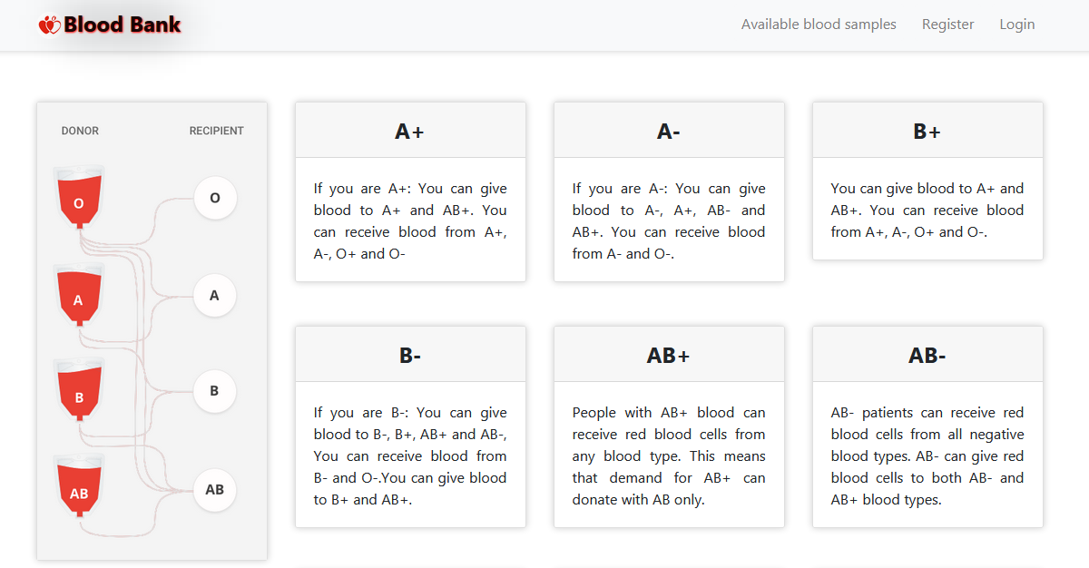

**7.2 ABOUT PAGE**

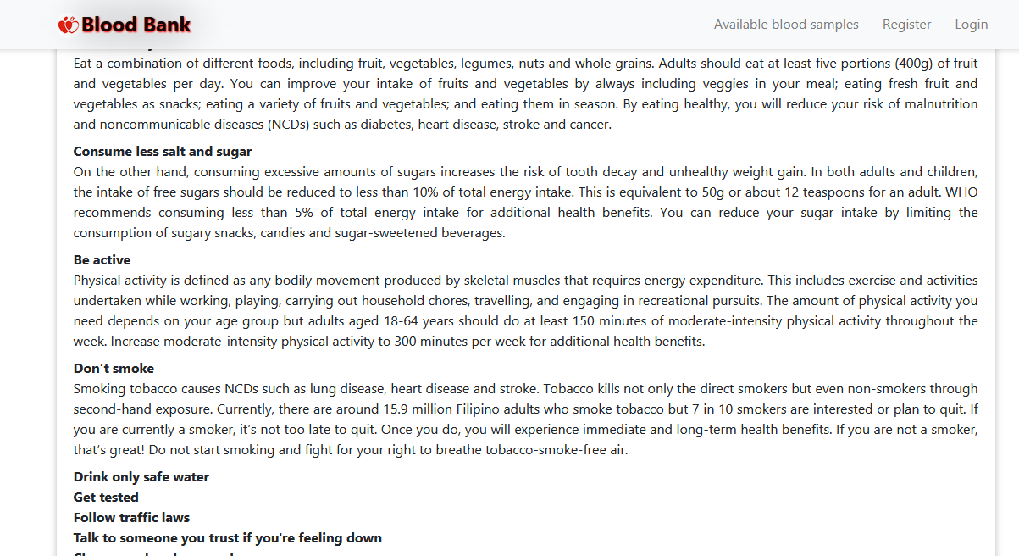

**7.3 BLOOD REQUST PAGE**

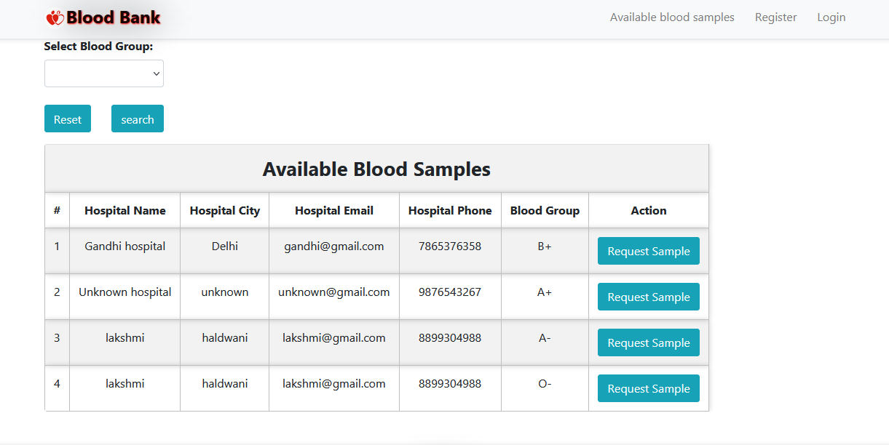

**7.4 HOASPITAL REGISTRATION PAGE**

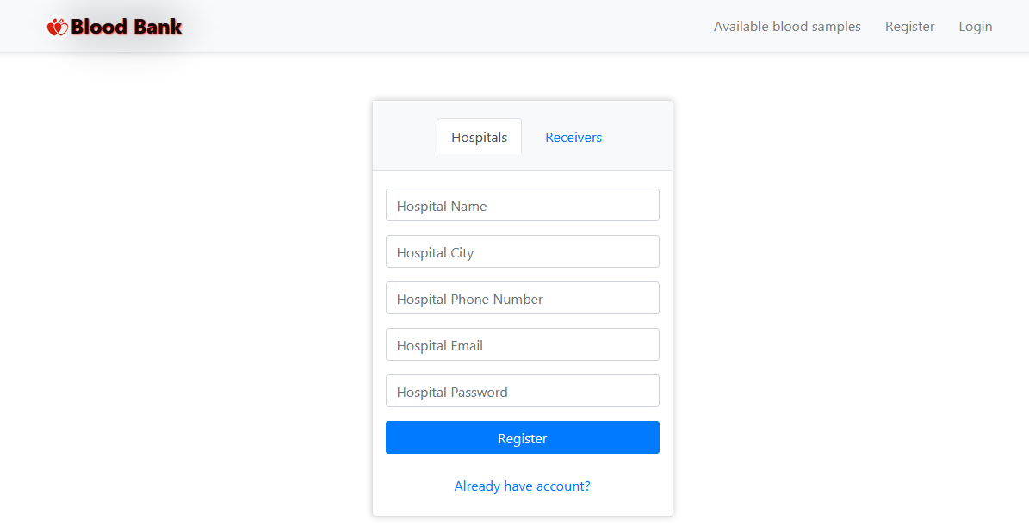

**7.5 RECIEVER REGISTRATION PAGE**

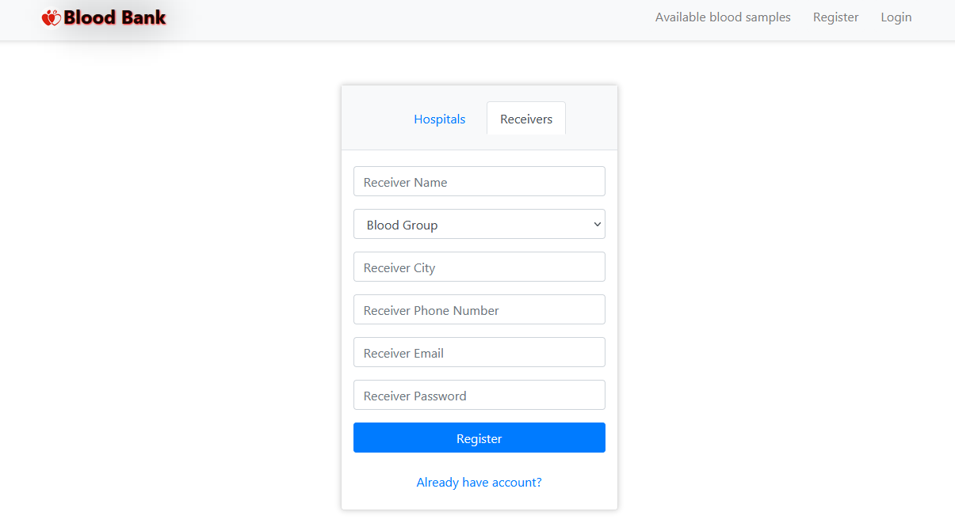

**7.6 LOGIN PAGE**

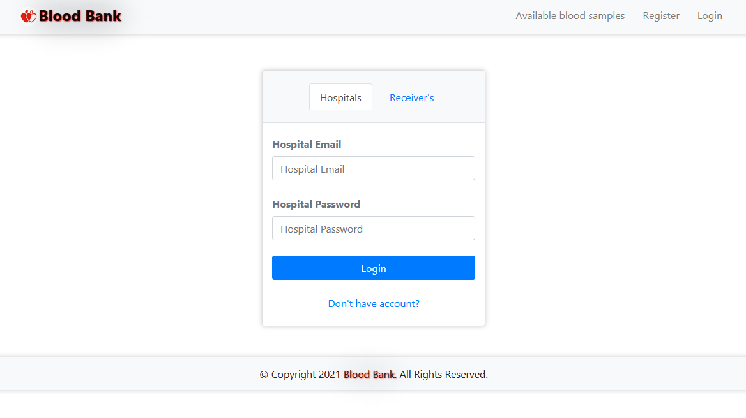

**7.8 AVILABLE BLOOD SAMPLE REQUEST**

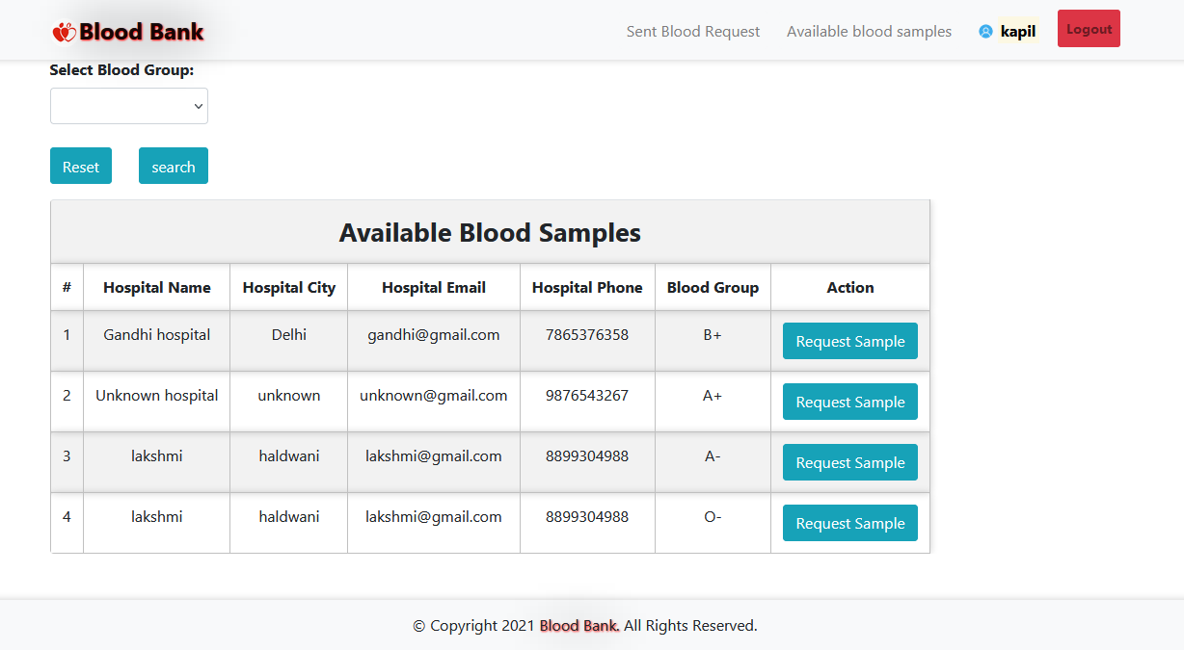

**7. 9 SENT REQUEST**

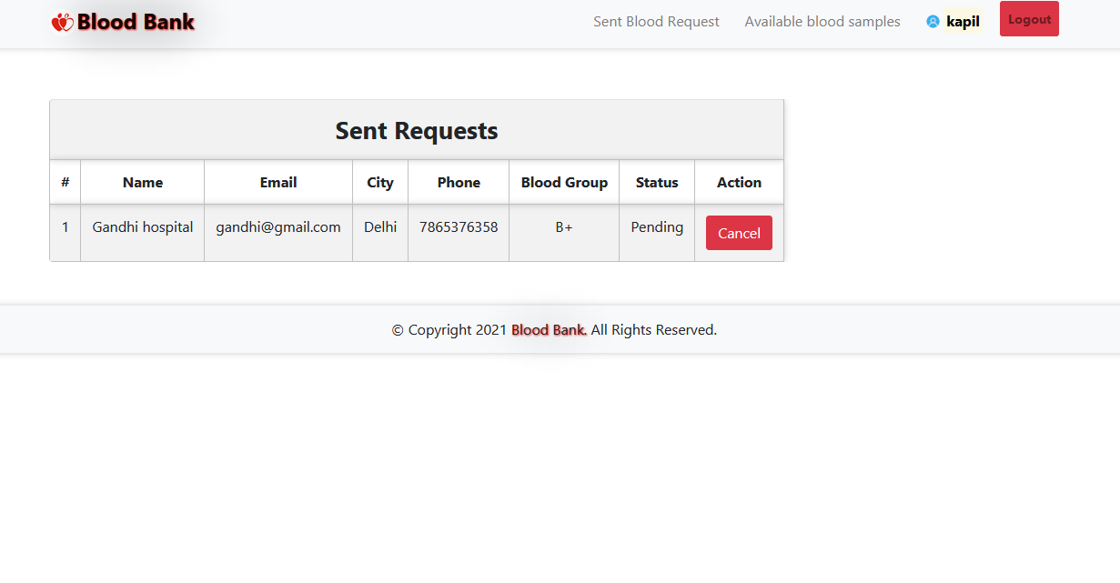

# 8. CODING AND FORMS RELATED TO WEBPAGE

## 8.1 HOME PAGE

**Index.php**

<!DOCTYPE html>

<html>

<head>

<title>Bloodbank | home page</title>

<meta charset="UTF-8" />

<meta name="viewport" content="width=device-width, initial-scale=1.0" />

<meta http-equiv="X-UA-Compatible" content="ie=edge" />

<link rel="stylesheet" href="[https://maxcdn.bootstrapcdn.com/bootstrap/4.5.0/css/bootstrap.min.css](view-source:https://maxcdn.bootstrapcdn.com/bootstrap/4.5.0/css/bootstrap.min.css)">

<script src="[https://cdnjs.cloudflare.com/ajax/libs/popper.js/1.16.0/umd/popper.min.js](view-source:https://cdnjs.cloudflare.com/ajax/libs/popper.js/1.16.0/umd/popper.min.js)"></script>

<script src="[https://maxcdn.bootstrapcdn.com/bootstrap/4.5.0/js/bootstrap.min.js](view-source:https://maxcdn.bootstrapcdn.com/bootstrap/4.5.0/js/bootstrap.min.js)"></script>

<link rel="stylesheet" type="text/css" href="[../library/css/bootstrap.min.css](view-source:http://localhost/library/css/bootstrap.min.css)"/>

<script type="text/javascript" src="[../library/js/jquery-3.2.1.min.js](view-source:http://localhost/library/js/jquery-3.2.1.min.js)"></script>

<script src="[https://ajax.googleapis.com/ajax/libs/jquery/3.5.1/jquery.min.js](view-source:https://ajax.googleapis.com/ajax/libs/jquery/3.5.1/jquery.min.js)"></script>

<script src="[https://stackpath.bootstrapcdn.com/bootstrap/4.5.0/js/bootstrap.min.js](view-source:https://stackpath.bootstrapcdn.com/bootstrap/4.5.0/js/bootstrap.min.js)"></script>

<script src="[https://kit.fontawesome.com/a076d05399.js](view-source:https://kit.fontawesome.com/a076d05399.js)"></script>

<link href="[css/style.css](view-source:http://localhost/bloodbank/css/style.css)" rel="stylesheet"/>

<link rel="shortcut icon" type="image/jpeg" href="[image/favicon.jpg](view-source:http://localhost/bloodbank/image/favicon.jpg)">

</head><body>

<nav class="navbar navbar-expand-sm navbar-light bg-light sticky-top">

<div class="container">

<a class="navbar-brand" href="[index.php](view-source:http://localhost/bloodbank/index.php)"><img src="[image/favicon.jpg](view-source:http://localhost/bloodbank/image/favicon.jpg)" width="30" height="30" class="rounded-circle">Blood Bank</a>

<button class="navbar-toggler" type="button" data-toggle="collapse" data-target="#collapsibleNavbar"><i class="fas fa-align-left"></i></span>

</button>

<div class="collapse navbar-collapse" id="collapsibleNavbar">

<ul class="navbar-nav ml-auto">

<li class="nav-item">

<a class="nav-link btn btn-light" href="[sentrequest.php](view-source:http://localhost/bloodbank/sentrequest.php)">Sent Blood Request</a>

</li>

<li class="nav-item">

<a class="nav-link btn btn-light" href="[abs.php](view-source:http://localhost/bloodbank/abs.php)">Available blood samples</a>

</li>

<li class="nav-item">

<a href="[rprofile.php?id=3](view-source:http://localhost/bloodbank/rprofile.php?id=3)" class="nav-link btn font-weight-bold" href="#"><img src="[image/user.png](view-source:http://localhost/bloodbank/image/user.png)" width="15" height="15" class="rounded-circle"> <mark> kapil</mark></a>

</li>

<li class="nav-item">

<a class="nav-link btn btn-danger btn-sm font-weight-bold" href="[logout.php](view-source:http://localhost/bloodbank/logout.php)">Logout</a>

</li>

</ul>

</div>

</div>

</nav>

<div class="container cont">

<div class="row justify-content-center mb-3">

</div>

<script src="[https://code.jquery.com/jquery-1.12.4.min.js](view-source:https://code.jquery.com/jquery-1.12.4.min.js)"></script>

<script>

$( document ).ready(function(){

$('#message').fadeIn('slow', function(){

$('#message').delay(5000).fadeOut();

});

});

</script>

<div class="row justify-content-center">

<div class="col-xl-3 col-lg-3 col-md-4 col-sm-5 col-xs-6 mb-5" style="width: 60%">

<div class="card">

<img src="[image/bg.png](view-source:http://localhost/bloodbank/image/bg.png)" class="card-img-top">

</div>

</div>

<div class="col-lg-9">

<div class="row">

<div class="col-xl-4 col-lg-4 col-md-6 col-sm-6 col-xs-12 mb-5">

<div class="card">

<div class="card-header text-center">A+</div>

<div class="card-body">

If you are A+: You can give blood to A+ and AB+. You can receive blood from A+, A-, O+ and O-

</div>

</div>

</div>

<div class="col-xl-4 col-lg-4 col-md-6 col-sm-6 col-xs-12 mb-5">

<div class="card">

<div class="card-header text-center">A-</div>

<div class="card-body">

If you are A-: You can give blood to A-, A+, AB- and AB+. You can receive blood from A- and O-.

</div>

</div>

</div>

<div class="col-xl-4 col-lg-4 col-md-6 col-sm-6 col-xs-12 mb-5">

<div class="card">

<div class="card-header text-center">B+</div>

<div class="card-body">

You can give blood to A+ and AB+. You can receive blood from A+, A-, O+ and O-.

</div>

</div>

</div>

<div class="col-xl-4 col-lg-4 col-md-6 col-sm-6 col-xs-12 mb-5">

<div class="card">

<div class="card-header text-center">B-</div>

<div class="card-body">

If you are B-: You can give blood to B-, B+, AB+ and AB-, You can receive blood from B- and O-.You can give blood to B+ and AB+.

</div>

</div>

</div>

<div class="col-xl-4 col-lg-4 col-md-6 col-sm-6 col-xs-12 mb-5">

<div class="card">

<div class="card-header text-center">AB+</div>

<div class="card-body">

People with AB+ blood can receive red blood cells from any blood type. This means that demand for AB+ can donate with AB only.

</div>

</div>

</div>

<div class="col-xl-4 col-lg-4 col-md-6 col-sm-6 col-xs-12 mb-5">

<div class="card">

<div class="card-header text-center">AB-</div>

<div class="card-body">

AB- patients can receive red blood cells from all negative blood types.

AB- can give red blood cells to both AB- and AB+ blood types.

</div>

</div>

</div>

<div class="col-xl-4 col-lg-4 col-md-6 col-sm-6 col-xs-12 mb-5">

<div class="card">

<div class="card-header text-center">O+</div>

<div class="card-body">

Blood O+ can donate to A+, B+, AB+ and O+ Blood

Group O can donate red blood cells to anybody. It's the universal donor.

</div>

</div>

</div>

<div class="col-xl-4 col-lg-4 col-md-6 col-sm-6 col-xs-12 mb-5">

<div class="card">

<div class="card-header text-center">O-</div>

<div class="card-body">

O- can donate to A+, A-, B+, B-, AB+, AB-, O+ and O- Blood

People with O negative blood can only receive red cell donations from O negative donors.

</div>

</div>

</div>

<div class="col-xl-4 col-lg-4 col-md-6 col-sm-6 col-xs-12 mb-5">

<div class="card">

<div class="card-header text-center">Admin contact</div>

<div class="card-body">

<i class="fa fa-envelope"> </i> <a > bloodbank@gmail.com</a><br><br>

<i class="fa fa-mobile"> </i> <a > +91 9876543210</a><br><br>

</div>

</div>

</div>

</div>

</div>

</div>

<div class="row">

<div class="col-lg-6 rounded mb-5">

</div>

<div class="col-lg-6 rounded mb-5">

</div>

</div>

<div class="row mb-5">

<div class="col-lg-12">

<div class="card">

<div class="card-header">Health tips</div>

<div class="card-body">

<dt>Eat a healthy diet</dt>

<dd>Eat a combination of different foods, including fruit, vegetables, legumes, nuts and whole grains. Adults should eat at least five portions (400g) of fruit and vegetables per day. You can improve your intake of fruits and vegetables by always including veggies in your meal; eating fresh fruit and vegetables as snacks; eating a variety of fruits and vegetables; and eating them in season. By eating healthy, you will reduce your risk of malnutrition and noncommunicable diseases (NCDs) such as diabetes, heart disease, stroke and cancer.</dd>

<dt> Consume less salt and sugar</dt>

<dd>On the other hand, consuming excessive amounts of sugars increases the risk of tooth decay and unhealthy weight gain. In both adults and children, the intake of free sugars should be reduced to less than 10% of total energy intake. This is equivalent to 50g or about 12 teaspoons for an adult. WHO recommends consuming less than 5% of total energy intake for additional health benefits. You can reduce your sugar intake by limiting the consumption of sugary snacks, candies and sugar-sweetened beverages.</dd>

<dt>Be active</dt>

<dd>Physical activity is defined as any bodily movement produced by skeletal muscles that requires energy expenditure. This includes exercise and activities undertaken while working, playing, carrying out household chores, travelling, and engaging in recreational pursuits. The amount of physical activity you need depends on your age group but adults aged 18-64 years should do at least 150 minutes of moderate-intensity physical activity throughout the week. Increase moderate-intensity physical activity to 300 minutes per week for additional health benefits.</dd>

<dt>Don’t smoke</dt>

<dd>Smoking tobacco causes NCDs such as lung disease, heart disease and stroke. Tobacco kills not only the direct smokers but even non-smokers through second-hand exposure. Currently, there are around 15.9 million Filipino adults who smoke tobacco but 7 in 10 smokers are interested or plan to quit.

If you are currently a smoker, it’s not too late to quit. Once you do, you will experience immediate and long-term health benefits. If you are not a smoker, that’s great! Do not start smoking and fight for your right to breathe tobacco-smoke-free air.</dd>

<dt>Drink only safe water</dt>

<dt>Get tested</dt>

<dt>Follow traffic laws</dt>

<dt>Talk to someone you trust if you're feeling down</dt>

<dt>Clean your hands properly</dt>

<dt>Have regular check-ups</dt>

Visit here to get more health tips.

<a href="[https://www.who.int/philippines/news/feature-stories/detail/20-health-tips-for-2020](view-source:https://www.who.int/philippines/news/feature-stories/detail/20-health-tips-for-2020)" target="_blank"> World Health Organisation</a>

</div>

</div>

</div>

</div>

</div>

<footer class="footer text-center bg-light">

© Copyright <span id="demo"></span> <span class="brand">Blood Bank. </span> All Rights Reserved.

<script>

date = new Date();

document.getElementById("demo").innerHTML=date.getFullYear();

</script>

</footer>

</body>

</html>

**…………………………………………………………………………………........**

## 8.2 SENT REQUST PAGE

## sentreq.php

<!DOCTYPE html>

<html>

<head>

<title>Bloodbank | Sent Requests</title>

<meta charset="UTF-8" />

<meta name="viewport" content="width=device-width, initial-scale=1.0" />

<meta http-equiv="X-UA-Compatible" content="ie=edge" />

<link rel="stylesheet" href="[https://maxcdn.bootstrapcdn.com/bootstrap/4.5.0/css/bootstrap.min.css](view-source:https://maxcdn.bootstrapcdn.com/bootstrap/4.5.0/css/bootstrap.min.css)">

<script src="[https://cdnjs.cloudflare.com/ajax/libs/popper.js/1.16.0/umd/popper.min.js](view-source:https://cdnjs.cloudflare.com/ajax/libs/popper.js/1.16.0/umd/popper.min.js)"></script>

<script src="[https://maxcdn.bootstrapcdn.com/bootstrap/4.5.0/js/bootstrap.min.js](view-source:https://maxcdn.bootstrapcdn.com/bootstrap/4.5.0/js/bootstrap.min.js)"></script>

<link rel="stylesheet" type="text/css" href="[../library/css/bootstrap.min.css](view-source:http://localhost/library/css/bootstrap.min.css)"/>

<script type="text/javascript" src="[../library/js/jquery-3.2.1.min.js](view-source:http://localhost/library/js/jquery-3.2.1.min.js)"></script>

<script src="[https://ajax.googleapis.com/ajax/libs/jquery/3.5.1/jquery.min.js](view-source:https://ajax.googleapis.com/ajax/libs/jquery/3.5.1/jquery.min.js)"></script>

<script src="[https://stackpath.bootstrapcdn.com/bootstrap/4.5.0/js/bootstrap.min.js](view-source:https://stackpath.bootstrapcdn.com/bootstrap/4.5.0/js/bootstrap.min.js)"></script>

<script src="[https://kit.fontawesome.com/a076d05399.js](view-source:https://kit.fontawesome.com/a076d05399.js)"></script>

<link href="[css/style.css](view-source:http://localhost/bloodbank/css/style.css)" rel="stylesheet"/>

<link rel="shortcut icon" type="image/jpeg" href="[image/favicon.jpg](view-source:http://localhost/bloodbank/image/favicon.jpg)">

</head><body>

<nav class="navbar navbar-expand-sm navbar-light bg-light sticky-top">

<div class="container">

<a class="navbar-brand" href="[index.php](view-source:http://localhost/bloodbank/index.php)"><img src="[image/favicon.jpg](view-source:http://localhost/bloodbank/image/favicon.jpg)" width="30" height="30" class="rounded-circle">Blood Bank</a>

<button class="navbar-toggler" type="button" data-toggle="collapse" data-target="#collapsibleNavbar"><i class="fas fa-align-left"></i></span>

</button>

<div class="collapse navbar-collapse" id="collapsibleNavbar">

<ul class="navbar-nav ml-auto">

<li class="nav-item">

<a class="nav-link btn btn-light" href="[sentrequest.php](view-source:http://localhost/bloodbank/sentrequest.php)">Sent Blood Request</a>

</li>

<li class="nav-item">

<a class="nav-link btn btn-light" href="[abs.php](view-source:http://localhost/bloodbank/abs.php)">Available blood samples</a>

</li>

<li class="nav-item">

<a href="[rprofile.php?id=3](view-source:http://localhost/bloodbank/rprofile.php?id=3)" class="nav-link btn font-weight-bold" href="#"><img src="[image/user.png](view-source:http://localhost/bloodbank/image/user.png)" width="15" height="15" class="rounded-circle"> <mark> kapil</mark></a>

</li>

<li class="nav-item">

<a class="nav-link btn btn-danger btn-sm font-weight-bold" href="[logout.php](view-source:http://localhost/bloodbank/logout.php)">Logout</a>

</li>

</ul>

</div>

</div>

</nav> <div class="container cont">

<div class="row justify-content-center mb-3">

</div>

<script src="[https://code.jquery.com/jquery-1.12.4.min.js](view-source:https://code.jquery.com/jquery-1.12.4.min.js)"></script>

<script>

$( document ).ready(function(){

$('#message').fadeIn('slow', function(){

$('#message').delay(5000).fadeOut();

});

});

</script>

<table class="table table-responsive table-striped rounded mb-5">

<tr><th colspan="8" class="title">Sent requests</th></tr>

<tr>

<th>#</th>

<th>Name</th>

<th>Email</th>

<th>City</th>

<th>Phone</th>

<th>Blood Group</th>

<th>Status</th>

<th>Action</th>

</tr>

<div>

</div>

<tr>

<td>1</td>

<td>Gandhi hospital</td>

<td>gandhi@gmail.com</td>

<td>Delhi</td>

<td>7865376358</td>

<td>B+</td>

<td>Pending</td>

<td> <a href="[file/cancel.php?reqid=2](view-source:http://localhost/bloodbank/file/cancel.php?reqid=2)" class="btn btn-danger">Cancel</a>

</td>

</tr>

</table>

</div>

<footer class="footer text-center bg-light">

© Copyright <span id="demo"></span> <span class="brand">Blood Bank. </span> All Rights Reserved.

<script>

date = new Date();

document.getElementById("demo").innerHTML=date.getFullYear();

</script>

</footer></body>

</html>

**…………………………………………………………………………………..............................**

## 8.3 AVAILABLE BLOOD SAMPLE PAGE

## abs.php

## <?php

## session_start();

## require 'file/connection.php';

## if(isset($_GET['search'])){

## $searchKey = $_GET['search'];

## $sql = "select bloodinfo.*, hospitals.* from bloodinfo, hospitals where bloodinfo.hid=hospitals.id && bg LIKE '%$searchKey%'";

## }else{

## $sql = "select bloodinfo.*, hospitals.* from bloodinfo, hospitals where bloodinfo.hid=hospitals.id";

## }

## $result = mysqli_query($conn, $sql);

## ?>

## <!DOCTYPE html>

## <html>

## <?php $title="Bloodbank | Available Blood Samples"; ?>

## <?php require 'head.php'; ?>

## <body>

## <?php require 'header.php'; ?>

## <div class="container cont">

## 

## <?php require 'message.php'; ?>

## 

## <div class="row col-lg-8 col-md-8 col-sm-12 mb-3">

## <form method="get" action="" style="margin-top:-20px; ">

## <label class="font-weight-bolder">Select Blood Group:</label>

## <select name="search" class="form-control">

## <option><?php echo @$_GET['search']; ?></option>

## <option value="A+">A+</option>

## <option value="A-">A-</option>

## <option value="B+">B+</option>

## <option value="B-">B-</option>

## <option value="AB+">AB+</option>

## <option value="AB-">AB-</option>

## <option value="O+">O+</option>

## <option value="O-">O-</option>

## </select><br>

## <a href="abs.php" class="btn btn-info mr-4"> Reset</a>

## <input type="submit" name="submit" class="btn btn-info" value="search">

## </form>

## </div>

## <table class="table table-responsive table-striped rounded mb-5">

## <tr><th colspan="7" class="title">Available Blood Samples</th></tr>

## <tr>

## <th>#</th>

## <th>Hospital Name</th>

## <th>Hospital City</th>

## <th>Hospital Email</th>

## <th>Hospital Phone</th>

## <th>Blood Group</th>

## <th>Action</th>

## </tr>

## <div>

## <?php

## if ($result) {

## $row =mysqli_num_rows( $result);

## if ($row) { //echo "<b> Total ".$row." </b>";

## }else echo '<b style="color:white;background-color:red;padding:7px;border-radius: 15px 50px;">Nothing to show.</b>';

## }

## ?>

## </div>

## <?php while($row = mysqli_fetch_array($result)) { ?>

## <tr>

## <td><?php echo ++$counter;?></td>

## <td><?php echo $row['hname'];?></td>

## <td><?php echo ($row['hcity']); ?></td>

## <td><?php echo ($row['hemail']); ?></td>

## <td><?php echo ($row['hphone']); ?></td>

## <td><?php echo ($row['bg']); ?></td>

## <?php $bid= $row['bid'];?>

## <?php $hid= $row['hid'];?>

## <?php $bg= $row['bg'];?>

## <form action="file/request.php" method="post">

## <input type="hidden" name="bid" value="<?php echo $bid; ?>">

## <input type="hidden" name="hid" value="<?php echo $hid; ?>">

## <input type="hidden" name="bg" value="<?php echo $bg; ?>">

## <?php if (isset($_SESSION['hid'])) { ?>

## <td><a href="javascript:void(0);" class="btn btn-info hospital">Request Sample</a></td>

## <?php } else {(isset($_SESSION['rid'])) ?>

## <td><input type="submit" name="request" class="btn btn-info" value="Request Sample"></td>

## <?php } ?>

## 

## </form>

## </tr>

## <?php } ?>

## </table>

## </div>

## <?php require 'footer.php' ?>

## </body>

## <script type="text/javascript">

## $('.hospital').on('click', function(){

## alert("Hospital user can't request for blood.");

## });

## </script> ………………………………………………………………………………………………………

**8.4 BLOOD INFORMATION PAGE**

**bloodinfo.php**

<?php

require 'file/connection.php';

session_start();

if(!isset($_SESSION['hid']))

{

header('location:login.php');

}

else {

?>

<!DOCTYPE html>

<html>

<?php $title="Bloodbank | Add blood samples"; ?>

<?php require 'head.php'; ?>

<body>

<?php require 'header.php'; ?>

<div class="container cont">

<?php require 'message.php'; ?>

<div class="row justify-content-center">

<div class="col-lg-4 col-md-5 col-sm-6 col-xs-7 mb-5">

<div class="card">

<div class="card-header title">Add blood group available in your hospital</div>

<div class="card-body">

<form action="[file/infoAdd.php](view-source:file:///C:/xampp/htdocs/bloodbank/file/infoAdd.php)" method="post">

<a data-toggle="collapse" href="[#collapseExample](view-source:file:///C:/xampp/htdocs/bloodbank/bloodinfo.php#collapseExample)" role="button" aria-expanded="false" aria-controls="collapseExample" title="click to see">Term & conditions. </a><br>

<div class="collapse" id="collapseExample">

If you have a blood sample tested by your doctor’s, nurse, or trained phlebotomist , at a pathology collection centre, clinic or hospital. Blood samples are most commonly taken from the inside of the elbow where the veins are usually closer to the surface. If before the needle is inserted, the area had been cleaned with an antiseptic cloth and blood sample is transferred into tubes containing the correct preservatives then add your blood group available in your hospital to your blood bank.<br><br>

</div>

<input type="checkbox" name="condition" value="agree" required> Agree<br><br>

<select class="form-control" name="bg" required="">

<option disabled selected>Blood Group</option>

<option>A-</option>

<option>A+</option>

<option>B-</option>

<option>B+</option>

<option>AB-</option>

<option>AB+</option>

<option>O-</option>

<option>O+</option>

</select><br>

<input type="submit" name="add" value="Add" class="btn btn-primary btn-block"><br>

<a href="[index.php](view-source:file:///C:/xampp/htdocs/bloodbank/index.php)" class="float-right" title="click here">Cancel</a>

</form>

</div>

</div>

</div>

<?php if(isset($_SESSION['hid'])){

$hid=$_SESSION['hid'];

$sql = "select * from bloodinfo where hid='$hid'";

$result = mysqli_query($conn, $sql);

}

?>

<div class="col-lg-4 col-md-5 col-sm-6 col-xs-7 mb-5">

<table class="table table-striped table-responsive">

<th colspan="4" class="title">Blood Bank</th>

<tr>

<th>#</th>

<th>Blood Samples</th>

<th>Action</th>

</tr>

<div>

<?php

if ($result) {

$row =mysqli_num_rows( $result);

if ($row) { //echo "<b> Total ".$row." </b>";

}else echo '<b style="color:white;background-color:red;padding:7px;border-radius: 15px 50px;">Nothing to show.</b>';

}

?>

</div>

<?php while($row = mysqli_fetch_array($result)) { ?>

<tr>

<td><?php echo ++$counter; ?></td>

<td><?php echo $row['bg'];?></td>

<td><a href="[file/delete.php?bid=<?php echo $row['bid'];?>](view-source:file:///C:/xampp/htdocs/bloodbank/file/delete.php?bid=%3C?php%20echo%20$row%5b%27bid%27%5d;?%3E)" class="btn btn-danger">Delete</a></td>

</tr>

<?php } ?>

</table>

</div>

</div>

</div>

<?php require 'footer.php' ?>

</body>

**……………………………………………………………………………………………**

**8.5 HOSPITAL PROFILE PAGE**

**hprofile.php**

<?php

require 'file/connection.php';

session_start();

if(!isset($_SESSION['hid']))

{

header('location:login.php');

}

else {

if(isset($_SESSION['hid'])){

$id=$_SESSION['hid'];

$sql = "SELECT * FROM hospitals WHERE id='$id'";

$result = mysqli_query($conn, $sql);

$row = mysqli_fetch_array($result);

}

}

?>

<!DOCTYPE html>

<html>

<?php $title="Bloodbank | Receiver Profile"; ?>

<?php require 'head.php';?>

<body>

<?php require 'header.php'; ?>

<div class="container cont">

<?php require 'message.php'; ?>

<div class="row justify-content-center">

<div class="col-lg-4 col-md-4 col-sm-6 mb-5">

<div class="card">

<div class="media justify-content-center mt-1">

<img src="image/hospital.png" alt="profile" class="rounded-circle" width="70" height="60">

</div>

<div class="card-body">

<form action="file/updateprofile.php" method="post">

<label class="text-muted font-weight-bold" class="text-muted font-weight-bold">Hospital Name</label>

<input type="text" name="hname" value="<?php echo $row['hname']; ?>" class="form-control mb-3">

<label class="text-muted font-weight-bold">Hospital Email</label>

<input type="email" name="hemail" value="<?php echo $row['hemail']; ?>" class="form-control mb-3">

<label class="text-muted font-weight-bold">Hospital Password</label>

<input type="text" name="hpassword" value="<?php echo $row['hpassword']; ?>" class="form-control mb-3">

<label class="text-muted font-weight-bold">Hospital Phone Number</label>

<input type="text" name="hphone" value="<?php echo $row['hphone']; ?>" class="form-control mb-3">

<label class="text-muted font-weight-bold">Hospital City</label>

<input type="text" name="hcity" value="<?php echo $row['hcity']; ?>" class="form-control mb-3">

<input type="submit" name="update" class="btn btn-block btn-primary" value="Update">

</form>

</div>

<a href="index.php" class="text-center">Cancel</a><br>

</div>

</div>

</div>

</div>

<?php require 'footer.php'; ?>

</body>

</html>

**………………………………………………………………………………………………………**

**8.6 LOGIN PAGE**

**login.php**

<?php

session_start();

if (isset($_SESSION['hid'])) {

header("location:bloodrequest.php");

}elseif (isset($_SESSION['rid'])) {

header("location:sentrequest.php");

}else{

?>

<!DOCTYPE html>

<html>

<?php $title="Bloodbank | Login"; ?>

<?php require 'head.php'; ?>

<body>

<?php require 'header.php'; ?>

<div class="container cont">

<?php require 'message.php'; ?>

<div class="row justify-content-center">

<div class="col-lg-4 col-md-5 col-sm-6 col-xs-7 mb-5">

<div class="card rounded">

<ul class="nav nav-tabs justify-content-center bg-light" style="padding: 20px;">

<li class="nav-item">

<a class="nav-link active" data-toggle="tab" href="#hospitals">Hospitals</a>

</li>

<li class="nav-item">

<a class="nav-link" data-toggle="tab" href="#receivers">Receiver's</a>

</li>

</ul>

<div class="tab-content">

<div class="tab-pane container active" id="hospitals">

<form action="file/hospitalLogin.php" method="post">

<label class="text-muted font-weight-bold" class="text-muted font-weight-bold">Hospital Email</label>

<input type="email" name="hemail" placeholder="Hospital Email" class="form-control mb-4">

<label class="text-muted font-weight-bold" class="text-muted font-weight-bold">Hospital Password</label>

<input type="password" name="hpassword" placeholder="Hospital Password" class="form-control mb-4">

<input type="submit" name="hlogin" value="Login" class="btn btn-primary btn-block mb-4">

</form>

</div>

<div class="tab-pane container fade" id="receivers">

<form action="file/receiverLogin.php" method="post">

<label class="text-muted font-weight-bold" class="text-muted font-weight-bold">Receiver Email</label>

<input type="email" name="remail" placeholder="Receiver Email" class="form-control mb-4">

<label class="text-muted font-weight-bold" class="text-muted font-weight-bold">Receiver Password</label>

<input type="password" name="rpassword" placeholder="Receiver Password" class="form-control mb-4">

<input type="submit" name="rlogin" value="Login" class="btn btn-primary btn-block mb-4">

</form>

</div>

</div>

<a href="register.php" class="text-center mb-4" title="Click here">Don't have account?</a>

</div>

</div>

</div>

</div>

<?php require 'footer.php' ?>

</body>

</html>

<?php } ?>

**……………………………………………………………………………………………………**

**8.7 LOGOUT PAGE**

**logout.php**

<?php

session_start();

session_unset();

session_destroy();

$msg="You have logged out.";

header( "location:index.php?msg=".$msg );

?>

**…………………………………………………………………………………………………………………………………………………………………………**

**8.8 MESSAGE PAGE**

**message.php**

<div class="row justify-content-center mb-3">

<?php $counter=0; if(isset($_GET['msg'])) { ?>

<div class="col-5 alert alert alert-success alert-dismissible fade show card" id="message">

<button type="button" class="close" data-dismiss="alert" title="close">&times;</button><?php echo $_GET['msg'];?>

</div>

<?php }?>

<?php if(isset($_GET['error'])) { ?>

<div class="col-5 alert error alert-danger alert-dismissible fade show card" id="message">

<button type="button" class="close" data-dismiss="alert" title="close">&times;</button><?php echo $_GET['error'];?>

</div>

<?php }?>

</div>

<script src="https://code.jquery.com/jquery-1.12.4.min.js"></script>

<script>

$( document ).ready(function(){

$('#message').fadeIn('slow', function(){

$('#message').delay(5000).fadeOut();

});

});

</script> **……………………………………………………………………………………………………..**

* 1. **REGISTER**

**register.php**

<?php

session_start();

if (isset($_SESSION['hid'])) {

header("location:bloodrequest.php");

}elseif (isset($_SESSION['rid'])) {

header("location:sentrequest.php");

}else{

?>

<!DOCTYPE html>

<html>

<?php $title="Bloodbank | Register"; ?>

<?php require 'head.php'; ?>

<body>

<?php include 'header.php'; ?>

<div class="container cont">

<?php require 'message.php'; ?>

<div class="row justify-content-center">

<div class="col-lg-4 col-md-5 col-sm-6 col-xs-7 mb-5">

<div class="card rounded">

<ul class="nav nav-tabs justify-content-center bg-light" style="padding: 20px">

<li class="nav-item">

<a class="nav-link active" data-toggle="tab" href="#hospitals">Hospitals</a>

</li>

<li class="nav-item">

<a class="nav-link" data-toggle="tab" href="#receivers">Receivers</a>

</li>

</ul>

<div class="tab-content">

<div class="tab-pane container active" id="hospitals">

<form action="file/hospitalReg.php" method="post" enctype="multipart/form-data">

<input type="text" name="hname" placeholder="Hospital Name" class="form-control mb-3" required>

<input type="text" name="hcity" placeholder="Hospital City" class="form-control mb-3" required>

<input type="tel" name="hphone" placeholder="Hospital Phone Number" class="form-control mb-3" required pattern="[0,6-9]{1}[0-9]{9,11}" title="Password must have start from 0,6,7,8 or 9 and must have 10 to 12 digit">

<input type="email" name="hemail" placeholder="Hospital Email" class="form-control mb-3" required>

<input type="password" name="hpassword" placeholder="Hospital Password" class="form-control mb-3" required minlength="6">

<input type="submit" name="hregister" value="Register" class="btn btn-primary btn-block mb-4">

</form>

</div>

<div class="tab-pane container fade" id="receivers">

<form action="file/receiverReg.php" method="post" enctype="multipart/form-data">

<input type="text" name="rname" placeholder="Receiver Name" class="form-control mb-3" required>

<select name="rbg" class="form-control mb-3" required>

<option disabled="" selected="">Blood Group</option>

<option value="A+">A+</option>

<option value="A-">A-</option>

<option value="B+">B+</option>

<option value="B-">B-</option>

<option value="AB+">AB+</option>

<option value="AB-">AB-</option>

<option value="O+">O+</option>

<option value="O-">O-</option>

</select>

<input type="text" name="rcity" placeholder="Receiver City" class="form-control mb-3" required>

<input type="tel" name="rphone" placeholder="Receiver Phone Number" class="form-control mb-3" required pattern="[0,6-9]{1}[0-9]{9,11}" title="Password must have start from 0,6,7,8 or 9 and must have 10 to 12 digit">

<input type="email" name="remail" placeholder="Receiver Email" class="form-control mb-3" required>

<input type="password" name="rpassword" placeholder="Receiver Password" class="form-control mb-3" required minlength="6">

<input type="submit" name="rregister" value="Register" class="btn btn-primary btn-block mb-4">

</form>

</div>

</div>

<a href="login.php" class="text-center mb-4" title="Click here">Already have account?</a>

</div>

</div>

</div>

</div>

<?php require 'footer.php' ?>

</body>

</html>

<?php } ?>

**……………………………………………………………………………………………………..**

**8.10.1 RECIEVER PROFILE PAGE**

**rprofile.php**

<?php

require 'file/connection.php';

session_start();

if(!isset($_SESSION['rid']))

{

header('location:login.php');

}

else {

if(isset($_SESSION['rid'])){

$id=$_SESSION['rid'];

$sql = "SELECT * FROM receivers WHERE id='$id'";

$result = mysqli_query($conn, $sql);

$row = mysqli_fetch_array($result);

}

}

?>

<!DOCTYPE html>

<html>

<?php $title="Bloodbank | Receiver Profile"; ?>

<?php require 'head.php';?>

<body>

<?php require 'header.php'; ?>

<div class="container cont">

<?php require 'message.php'; ?>

<div class="row justify-content-center">

<div class="col-lg-4 col-md-6 col-sm-8 mb-5">

<div class="card">

<div class="media justify-content-center mt-1">

<img src="image/user.png" alt="profile" class="rounded-circle" width="60" height="60">

</div>

<div class="card-body">

<form action="file/updateprofile.php" method="post">

<label class="text-muted font-weight-bold" class="text-muted font-weight-bold">Receiver Name</label>

<input type="text" name="rname" value="<?php echo $row['rname']; ?>" class="form-control mb-3">

<label class="text-muted font-weight-bold" class="text-muted font-weight-bold">Receiver Email</label>

<input type="email" name="remail" value="<?php echo $row['remail']; ?>" class="form-control mb-3">

<label class="text-muted font-weight-bold" class="text-muted font-weight-bold">Receiver Password</label>

<input type="text" name="rpassword" value="<?php echo $row['rpassword']; ?>" class="form-control mb-3">

<label class="text-muted font-weight-bold" class="text-muted font-weight-bold">Receiver Phone Number</label>

<input type="text" name="rphone" value="<?php echo $row['rphone']; ?>" class="form-control mb-3">

<label class="text-muted font-weight-bold" class="text-muted font-weight-bold">Receiver City</label>

<input type="text" name="rcity" value="<?php echo $row['rcity']; ?>" class="form-control mb-3">

<label class="text-muted font-weight-bold" class="text-muted font-weight-bold">Receiver Blood Group</label>

<select class="form-control mb-3" name="bg" required>

<option selected><?php echo $row['rbg']; ?></option>

<option>A-</option>

<option>A+</option>

<option>B-</option>

<option>B+</option>

<option>AB-</option>

<option>AB+</option>

<option>O-</option>

<option>O+</option>

</select>

<input type="submit" name="update" class="btn btn-block btn-primary" value="Update">

</form>

</div>

<a href="index.php" class="text-center">Cancel</a><br>

</div>

</div>

</div>

</div>

<?php require 'footer.php'; ?>

</body>

</html> **…………………………………………………………………………………………………….**

**8.11 SENT REQUST PAGE**

**sentrequest.php**

<?php

require 'file/connection.php';

session_start();

if(!isset($_SESSION['rid']))

{

header('location:login.php');

}

else {

$rid = $_SESSION['rid'];

$sql = "select bloodrequest.*, hospitals.* from bloodrequest, hospitals where rid='$rid' && bloodrequest.hid=hospitals.id";

$result = mysqli_query($conn, $sql);

?>

<!DOCTYPE html>

<html>

<?php $title="Bloodbank | Sent Requests"; ?>

<?php require 'head.php'; ?>

<body>

<?php require 'header.php'; ?>

<div class="container cont">

<?php require 'message.php'; ?>

<table class="table table-responsive table-striped rounded mb-5">

<tr><th colspan="8" class="title">Sent requests</th></tr>

<tr>

<th>#</th>

<th>Name</th>

<th>Email</th>

<th>City</th>

<th>Phone</th>

<th>Blood Group</th>

<th>Status</th>

<th>Action</th>

</tr>

<div>

<?php

if ($result) {

$row =mysqli_num_rows( $result);

if ($row) { //echo "<b> Total ".$row." </b>";

}else echo '<b style="color:white;background-color:red;padding:7px;border-radius: 15px 50px;">You have not requested yet. </b>';

}

?>

</div>

<?php while($row = mysqli_fetch_array($result)) { ?>

<tr>

<td><?php echo ++$counter;?></td>

<td><?php echo $row['hname'];?></td>

<td><?php echo $row['hemail'];?></td>

<td><?php echo $row['hcity'];?></td>

<td><?php echo $row['hphone'];?></td>

<td><?php echo $row['bg'];?></td>

<td><?php echo $row['status'];?></td>

<td><?php if($row['status'] == 'Accepted'){ ?>

<?php }

else{ ?>

<a href="[file/cancel.php?reqid=<?php echo $row['reqid'];?>](view-source:file:///C:/xampp/htdocs/bloodbank/file/cancel.php?reqid=%3C?php%20echo%20$row%5b%27reqid%27%5d;?%3E)" class="btn btn-danger">Cancel</a>

<?php } ?>

</td>

</tr>

<?php } ?>

</table>

</div>

<?php require 'footer.php'; ?>

</body>

</html>

<?php } ?>

**…………………………………………………………………………………………………….**

**8.12 HEADER PAGE**

**header.php**

<nav class="navbar navbar-expand-sm navbar-light bg-light sticky-top">

<div class="container">

<a class="navbar-brand" href="index.php"><img src="image/favicon.jpg" width="30" height="30" class="rounded-circle">Blood Bank</a>

<button class="navbar-toggler" type="button" data-toggle="collapse" data-target="#collapsibleNavbar"><i class="fas fa-align-left"></i></span>

</button>

<div class="collapse navbar-collapse" id="collapsibleNavbar">

<?php if (isset($_SESSION['hid'])) { ?>

<ul class="navbar-nav ml-auto">

<li class="nav-item">

<a class="nav-link btn btn-light" href="bloodinfo.php">Add blood info</a>

</li>

<li class="nav-item">

<a class="nav-link btn btn-light" href="bloodrequest.php">Blood Request</a>

</li>

<li class="nav-item">

<a class="nav-link btn btn-light" href="abs.php">Available blood samples</a>

</li>

<li class="nav-item">

<a href="hprofile.php?id=<?php echo $_SESSION['hid']; ?>" class="nav-link btn font-weight-bold"><img src="image/hospital.png" width="15" height="15" class="rounded-circle"><mark><?php echo $_SESSION['hname']; ?></mark></a>

</li>

<li class="nav-item">

<a class="nav-link btn btn-danger btn-sm font-weight-bold" href="logout.php">Logout</a>

</li>

</ul>

<?php } elseif (isset($_SESSION['rid'])) { ?>

<ul class="navbar-nav ml-auto">

<li class="nav-item">

<a class="nav-link btn btn-light" href="sentrequest.php">Sent Blood Request</a>

</li>

<li class="nav-item">

<a class="nav-link btn btn-light" href="abs.php">Available blood samples</a>

</li>

<li class="nav-item">

<a href="rprofile.php?id=<?php echo $_SESSION['rid']; ?>" class="nav-link btn font-weight-bold" href="#"><img src="image/user.png" width="15" height="15" class="rounded-circle"> <mark><?php echo ' '.$_SESSION['rname']; ?></mark></a>

</li>

<li class="nav-item">

<a class="nav-link btn btn-danger btn-sm font-weight-bold" href="logout.php">Logout</a>

</li>

</ul>

<?php } else { ?>

<ul class="navbar-nav ml-auto">

<li class="nav-item">

<a class="nav-link btn btn-light" href="abs.php">Available blood samples</a>

</li>

<li class="nav-item">

<a class="nav-link btn btn-light" href="register.php">Register</a>

</li>

<li class="nav-item">

<a class="nav-link btn btn-light" href="login.php">Login</a>

</li>

</ul>

<?php } ?>

</div>

</div>

</nav> **…………………………………………………………………………………………………….**

**8.13 HEAD**

**head.php**

<head>

<title><?php echo $title ?></title>

<meta charset="UTF-8" />

<meta name="viewport" content="width=device-width, initial-scale=1.0" />

<meta http-equiv="X-UA-Compatible" content="ie=edge" />

<link rel="stylesheet" href="https://maxcdn.bootstrapcdn.com/bootstrap/4.5.0/css/bootstrap.min.css">

<script src="https://cdnjs.cloudflare.com/ajax/libs/popper.js/1.16.0/umd/popper.min.js"></script>

<script src="https://maxcdn.bootstrapcdn.com/bootstrap/4.5.0/js/bootstrap.min.js"></script>

<link rel="stylesheet" type="text/css" href="../library/css/bootstrap.min.css"/>

<script type="text/javascript" src="../library/js/jquery-3.2.1.min.js"></script>

<script src="https://ajax.googleapis.com/ajax/libs/jquery/3.5.1/jquery.min.js"></script>

<script src="https://stackpath.bootstrapcdn.com/bootstrap/4.5.0/js/bootstrap.min.js"></script>

<script src="https://kit.fontawesome.com/a076d05399.js"></script>

<link href="css/style.css" rel="stylesheet"/>

<link rel="shortcut icon" type="image/jpeg" href="image/favicon.jpg">

</head> **…………………………………………………………………………………………………….**

**8.14 FOOTER**

**footer.php**

<footer class="footer text-center bg-light">

© Copyright <span id="demo"></span> <span class="brand">Blood Bank. </span> All Rights Reserved.

<script>

date = new Date();

document.getElementById("demo").innerHTML=date.getFullYear();

</script>

</footer> **…………………………………………………………………………………………………….**

**9. SYSTEM TESTING**

Testing is the process of executing a program with the intent of finding any errors. Testing is vital to the success of the system. Without proper testing hide errors will surface after sometime of use and perhaps irreversible damage has been done to valuable data. A series of tests like responsiveness, its value, stress and security are performed before the system is ready for user acceptance testing. System testing follows the logical conclusion that is all part of the system are tested and found to be working properly under all kinds of situations, and then the system is achieving its goal of processing the data perfectly according to user rules and requirements.

The different types of testing are given below.

1. Unit testing
2. Validation testing
3. Output testing
4. User acceptance testing

## 9.1 UNIT TESTING

It involves the basic testing of a piece of code, the size of which is often undefined in practice. During the unit testing it is tested to know whether that particular unit in the proper manner as expecting, if not appropriate modifications are applied to get proper outputs

## 9.2 VALIDATION TESTING

At the conclusion of the black box testing, software is completely assembled as a package.

Interfacing errors have been uncovered and correct and final series of test, i.e. validation begins. Validation test van is defined with a simple definition that validation succeeds when the software functions in a manner that can be reasonably accepted by the customer. Thus we have successfully done validation testing.

**9.3 OUTPUT TESTING**

After performing the validation testing, next is the output testing of the proposed system. The system cannot be useful if it not produce required output. The output displayed by the system under consideration will be compared with the user needs. Here the output format is considered in 2 ways, screen format and printed format. The output format on the screen is found to be correct as the format was defined in the design phase according to user needs. As for the hardcopy the output comes according to the specification requested by the user. Here the output testing does not result in any correction in the system. Thus we have successfully done output testing.

## 9.4 USER ACCEPTANCE TESTING

It is the key for success of any system. The system under consideration is tested for user acceptance by constantly keeping in touch with perspective system at the time of development and making changes whenever required. This is done with regarding to the input screen design and output screen design. Thus we have successfully done user acceptance testing.

## 9.5 STRATEGIC APPROACH TO SOFTWARE TESTING

The software engineering process can be viewed as a spiral. Initially system engineering defines the role of software and leads to software requirement analysis where the information domain, functions, behavior, performance, constraints and validation criteria for software are established. Moving inward along the spiral, we come to design and finally to coding. To develop computer software, we spiral in along streamlines that decrease the level of abstraction on each turn.

COMPONENT

TESTING

INTEGRATION TESTING

USER TESTING



UNI

T TESTING



MODULE TESTING



SUB

-

SYSTEM TESING



SYSTEM TESTING



ACCEPTANCE

TESTING

**STRATEGIC APPROACH TO SOFTWARE TESTING**

## WHITE BOX TESTING

This type of testing ensures that:

* All independent paths have been exercised at least once
* All logical decisions have been exercised on their true and false sides
* All loops are executed at their boundaries and within their operational bounds • all internal data structures have been exercised to assure their validity.

To follow the concept of white box testing we have tested each form. We have created independently to verify that Data flow is correct, all conditions are exercised to check their validity, all loops are executed on their boundaries.

## DATA FLOW TESTING

This type of testing selects the path of the program according to the location of definition and use of variables. This kind of testing was used only when some local variable was declared. The definition-use chain method was used in this type of testing. These were particularly useful in nested statements.

## LOOP TESTING

In this type of testing all the loops are tested to all the limits possible. The following exercise was adopted for all loops:

* All the loops were tested at their limits, just above them and just below them.
* All the loops were skipped at least once.
* For nested loops test the inner most loop first and then work outwards.
* For concatenated loops the values of dependent loops were set with the help of connected loop. • Unstructured loops were resolved into nested loops or concatenated loops and tested as above.

## CONDITIONAL TESTING

In this part of the testing each of the conditions were tested to both true and false aspects. And all the resulting paths were tested. So, that each path that may be generate on condition is traced to uncover any possible errors.

# 10. CONCLUSION

It has been a great pleasure for me to work on this exciting and challenging project. This project proved good for me as it provided practical knowledge of not only programming in PHP and DHTML web based application**.** It also provides knowledge about the latest technology used in developing web enabled application and client server technology that will be great demand in future. This will provide better opportunities and guidance in future in developing projects independently.

**BENEFITS:**

The project is identified by the merits of the system offered to the user. The merits of this project are as follows: -

* It’s a web-enabled project.
* This project offers user to enter the data through simple and interactive forms. This is very helpful for the client to enter the desired information through so much simplicity.
* The user is mainly more concerned about the validity of the data, whatever he is entering. There are checks on every stage of any new creation, data entry or updating so that the user cannot enter the invalid data, which can create problems at later date.
* Sometimes the user finds in the later stages of using project that he needs to update some of the information that he entered earlier. There are options for him by which he can update the records. Moreover, there is restriction for his that he cannot change the primary data field. This keeps the validity of the data to longer extent.
* User is provided the option of monitoring the records he entered earlier. He can see the desired records with the variety of options provided by him.
* From every part of the project the user is provided with the links through framing so that he can go from one option of the project too other as per the requirement. This is bound to be simple and very friendly as per the user is concerned. That is, we can say that the project is user friendly which is one of the primary concerns of any good project.

**11. BIBLIOGRAPHY**

• Software Engineering by Richard Fireclay

• www.tutorialspoint.com

• www.studytonight.com

• www.wikipedia.org

• www.w3school.com